Lorenzo’s Garden Favors

**ORDER FORM**

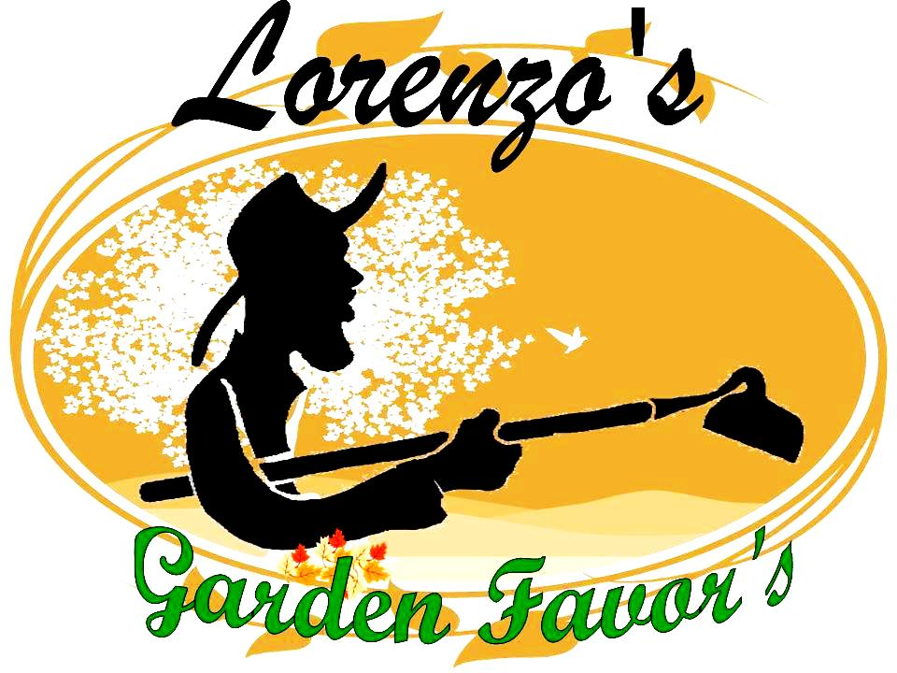

**Name:**

**Email add:**

**Contact Number:**

**Specify Date of Events:**

**Motiff/color theme:**

**Event theme setting:**

*(ex.garden,beach,western, vintage, rustic,etc wedding/party/reunion/graduation/gifts)*

**Place of Events/Location :**

**Type of events:**

**Quantity of orders:**

|  |  |
| --- | --- |
| **Date of delivery** |  |

**Herb/plant favor selection**  
 Aloevera   
 Chives  
 cactus

 Mint

 Marjoram

 Rosemary  
 Sweet Basil

 Stevia

Strawberry Plant  
 Thyme

 Tarragon

 Herb Vinegar

 Italian Oregano

 Lavender

 Lettuce

If you choose Mint

Mark Selected Variety

 Apple Mint  
 Chocolate Mint

 Lemon Mint (new)

 Pepper Mint

 Java Mint  
 Swiss Mint (best seller)

 Vietnamese Mint (rauram)

**Any request (herb/plant (if any)** 

**Type of pot**

 terracota clay pot  
 coco pot  
 special request(___________________)

**Pot Design**

 plain  
  brick (design)

 custom made design

**Choose design for your pot**

 pebbles (plain white)  
  live moss

 Dry moss

 none

**Choose your Carrier**

 Abaca herb Carrier  
  Basket carrier

**Choose your set of favors**

 Single Set (Single herb Carrier)   
  2 in 1set (2 potted Herbs in 1 carrier)

 3 in 1set (3 mini potted Herbs in 1 carrier)

**For custom color request of pebbles/rock please indicate color**

**For more additional request please indicate (if any)? Please specify**

**request.**



**Names on tag (ex. John & Sarah):**

**Date to be used on tag:** 

**Name of Place/event on tag (ex. Manila Cathedral):**

|  |  |
| --- | --- |
| **MODE OF PAYMENT:The downpayment equivalent to 50% is required (non refundable) upon confirmation of purchase order. No cancellation of order.  Remaining balance should be paid upon delivery/meetups**  **For Rush Order full payment should paid upon delivery.**  **DELIVERY: Pick up/Meetup's only (no courier to avoid damage of the plant/design) please contact us.** | |
|  |

We're delighted that you've visited our site and welcome your inquiry or emails. Your suggestions, comments, and feedback continue to allow us to bring you the personalized eco friendly party favors that you love.

God Bless &

Enjoy your party!